MOSHER MCGRAW LACROSSE

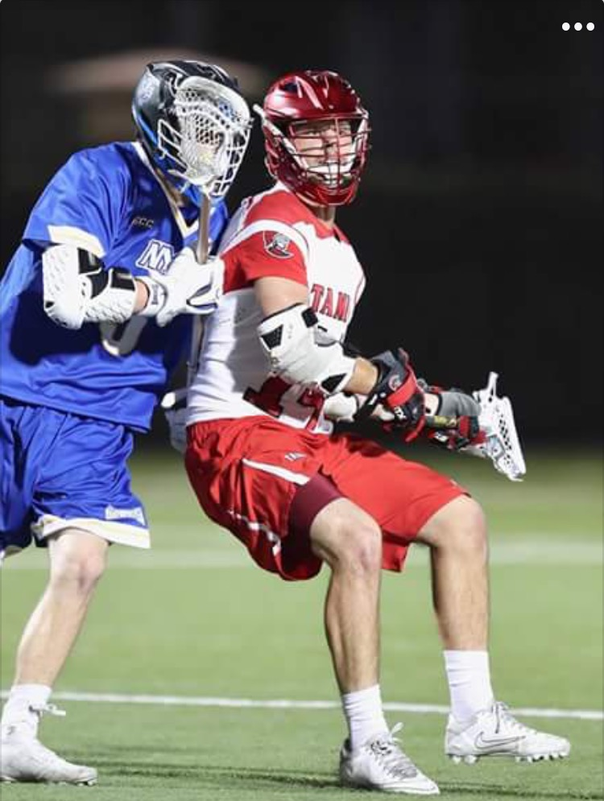
“The purpose of these clinics will be to improve the players fundamental lacrosse skills such as: Passing, Catching, Ball Handling, Shooting, Dodging & Defense. Additionally, working on Pick & Roll offense and defense systems.” – Jake Mosher McGraw

Clinics will be located at the Belyea and Gorman Arenas through the month of June 2018.

Clinic Coach: Jake, a Saint John native, plays field lacrosse in the NCAA for The University of Tampa Spartans. (2017 & 2018) He also plays box lacrosse in the ECJLL for the New Brunswick Mavericks. (2016, 2017 & 2018)

Achievements:
- 2018 NCAA Division II All-American
- 2018 NCAA SSC First Team All Star
- 2017 ECJLL First Team All Star
- 2017 NCAA SSC Second Team All Star

Dates, Locations & Age Groupings

Tyke & Novice:
Monday June 4th @6pm Belyea Arena
Sunday June 10th @10am Gorman Arena
Monday June 11th @6pm Belyea Arena
Friday June 15th @6pm Gorman Arena
Wednesday June 20th @6pm Gorman Arena
Monday June 25th @6pm Gorman Arena
Peewee & Bantam
Monday June 4th @7pm Belyea Arena
Sunday June 10th @11am Gorman Arena
Monday June 11th @7pm Belyea Arena
Friday June 15th @7pm Gorman Arena
Wednesday June 20th @7pm Gorman Arena
Monday June 25th @7pm Gorman Arena

Details:
- Registration fee is $60
- Payment options include: E-transfer to: jakemcgraw@zoho.com or cash payment
- Deadline for payment is Saturday June 2nd
- Fees do not apply for goalies.
- FLA Team Coaches are encouraged to come on the floor and watch the practice drills for their own teams.

Registration Form
Player Name:_____________________________________________________________
Division: Tyke Novice Peewee Bantam
FLA Team:___________________________________________________________
Stick Hand: Left Right
Email:_____________________________________________________________________
Phone:____________________________________________________________________
Payment method:________________________________________________________

***Email this Form to jakemcgraw@zoho.com if interested***

